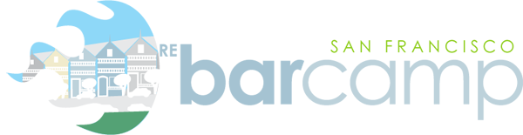

2008 RE Bar Camp San Francisco
July 22, 2008

SAN FRANCISCO, Calif. (January 2008) On Tuesday, July 22, 2008, real estate industry professionals will gather in San Francisco for the RE BarCamp San Francisco 2008, a participant-created conference for the real estate community. The participant-created conference breaks the mold of traditional conferences by engaging attendees and allowing anyone to present. This intense event will feature demos and panel discussions about technology in the real estate industry and will include heavy interaction with event attendees who are called “campers”.
RE BarCamp SF Organizer Andy Kaufman says: “The concept may sound a bit anarchistic & chaotic, but I’ve participated in these types of events before and my experiences from them stand among my favorites out of any conference that I’ve ever attended.”
The idea started in Palo Alto with a group that was bored by the typical business conference. The goal of the “participant-created conference” is to eliminate the stuffy conference atmosphere and let the campers truly shape the event. Camp attendees are responsible for creating the content and delivering the presentations. The atmosphere is interactive, informal and fun. BarCamps have been a resounding success around the world.
RE BarCamp SanFrancisco 2008 Event Details
RE BarCamp San Francisco will take place on Tuesday, July 22. Speakers and discussion panel members who have signed up to talk so far include:
- Todd Carpenter - Brainious
- Mike Price – mlbroadcast
- Jeff Turner- Real Estate Shows
- Dustin Luther – 4Realz
The event is free for attendees and is being sponsored by Agent Genius.com, Brainious.com, FBS Blog, Jim Duncan/RealCentralVA.com, MLBroadcast.Com, MyEastBayAgent, NoBlogger Left Behind, RealEstateZebra, Virginia Association of Realtors, ZillowBlog, Zipvo.com, and Trulia.
For more information and to reserve your spot at this event, visit www.rebarcamp.com.
###
Media Contact: Ginger Wilcox, gwilcox@pacunion.com, (415) 464-3725

